**EXPERIMENT 3**

**Prediction of Missing Data using Linear Regression and Interpolation**

**ACTIVITY -0**

**Interpolation**

Problem statement:

Let predict temperature through interpolation technique . The Data given point are as follows.

Recorded temperatures:

Time: 2.0 hours, Temperature: 9.0°C

Time: 3.0 hours, Temperature: 6.0°C

Time: 4.0 hours, Temperature: 12.0°C

Predict the temperature: 3.5 hours?

Sample python program is given below to assist in solving prediction problem with imported library. Solve same using without using ready made function.

---------------------------------------------------------------------------------------

import numpy as np

# Sample data points

known_x = [1, 2, 3, 4, 5]

known_y = [5, 9, 6, 12, 8]

# New data point to predict

new_x = 3.5

# Perform linear interpolation

interp_value = np.interp(new_x, known_x, known_y)

print(f"Interpolated value at x = {new_x}: {interp_value}")

**ACTIVITY -1**

Identify attributes suitable for applying Linear regression. Construct a linear regression model for your dataset and predict the missing values in your data set. Evaluate the accuracy of prediction.(usage of built in package for prediction is not expected)

**Single Linear Regression**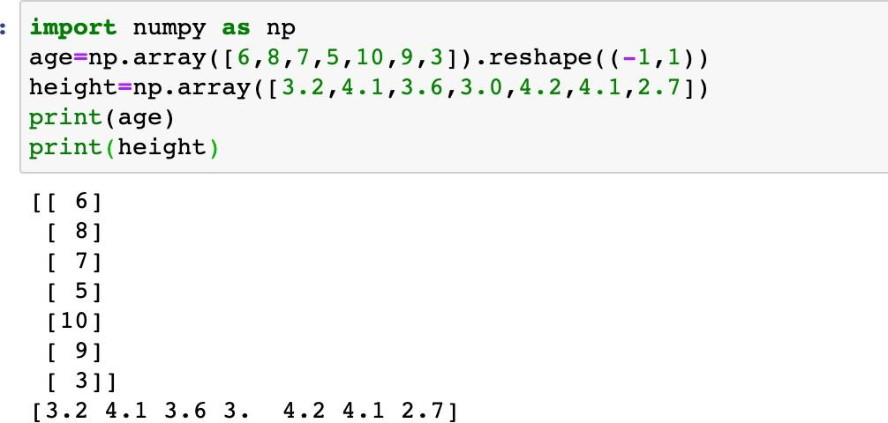

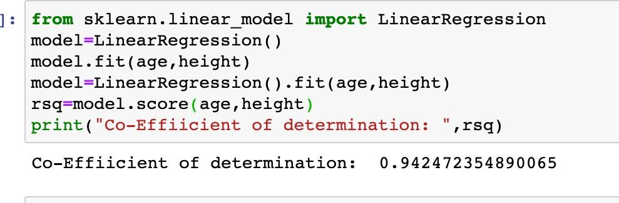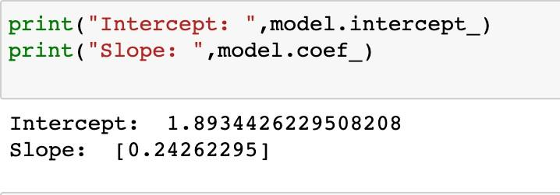

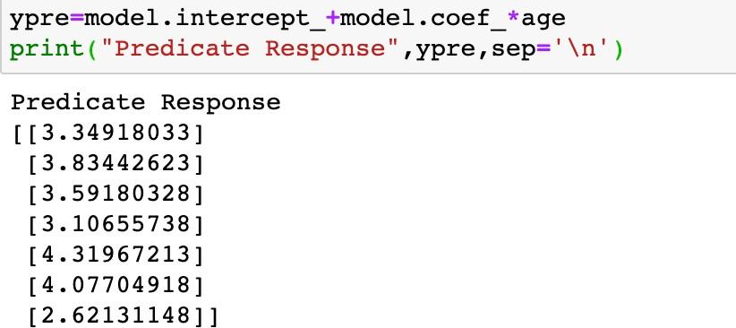

**Single Linear Regression without readymade functions**

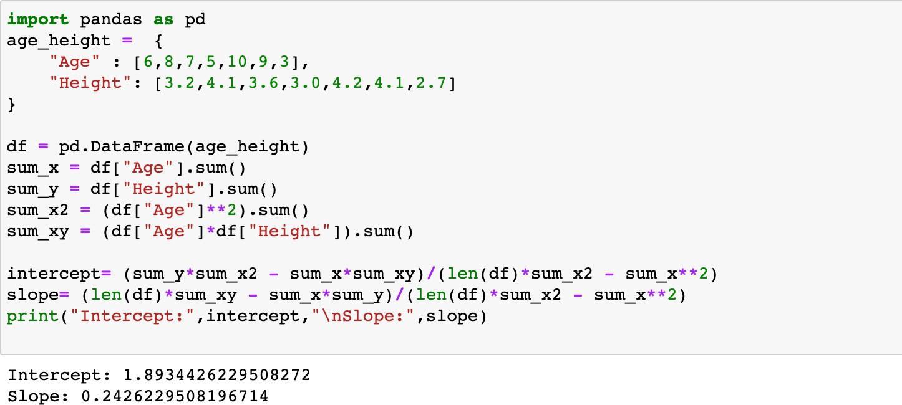

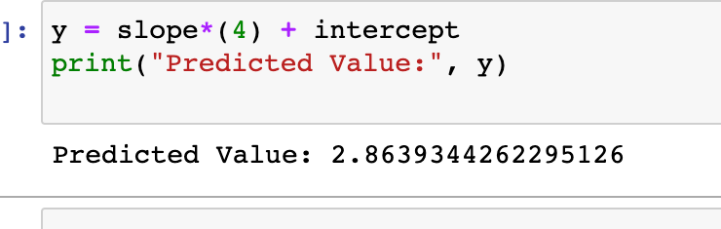

**You may find that the Predicted value by manual calculation is same as that obtained by using library functions.**

**ACTIVITY -2**

Identify attributes suitable for applying Multiple Linear regression. Construct a linear regression model for your dataset and predict the missing values in your data set. Evaluate the accuracy of prediction. .(usage of built in package for prediction is not expected)

**Multiple Linear Regression**

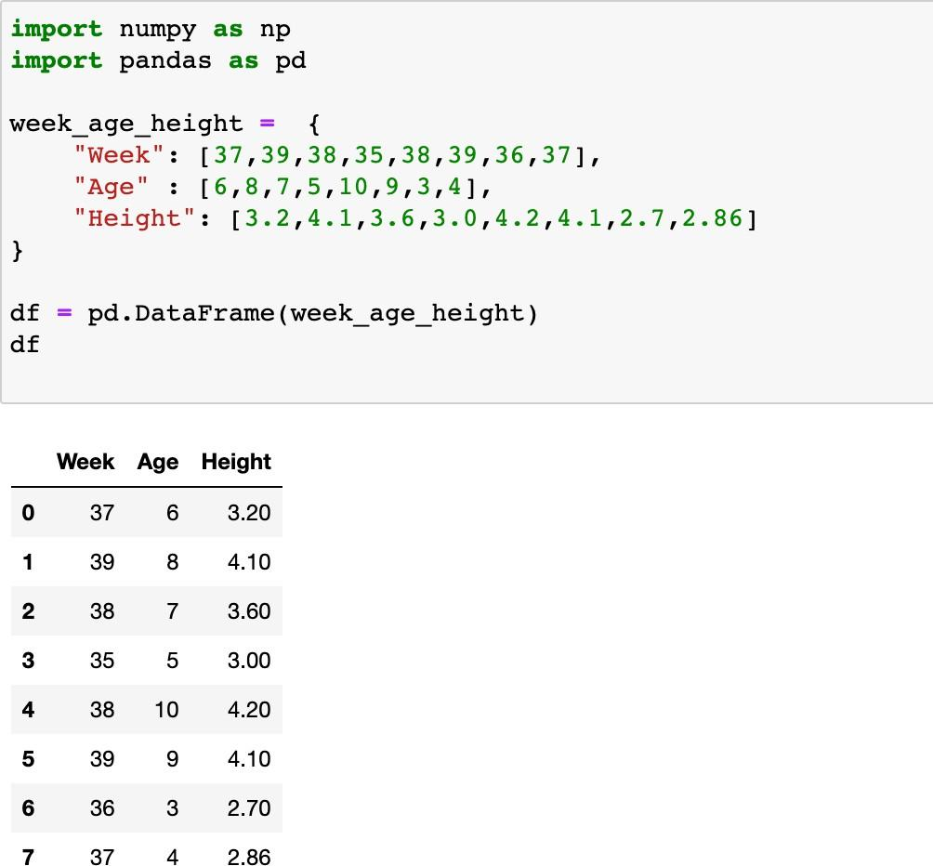

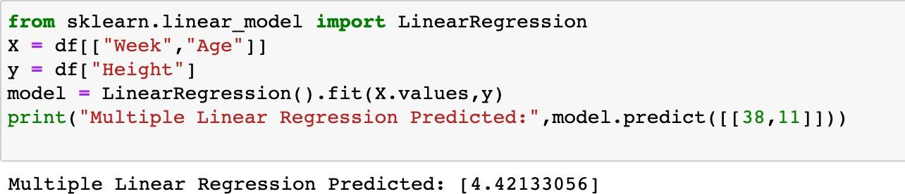

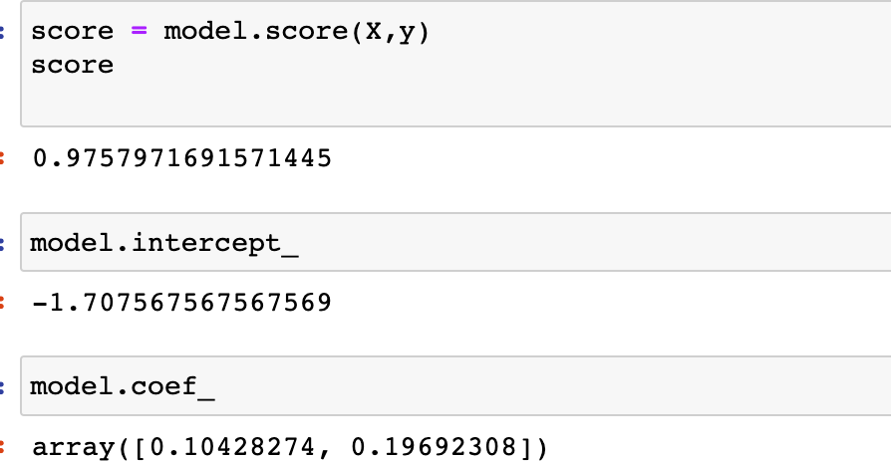

**Multiple Regression without ready made functions**

